Lesson 1 Homework  FRONT PAGE | LT 4.1 | 1-6, 14-18, 21-26 (FRONT PAGE)  32, 33, 35, 15, 16 (BACK PAGE)
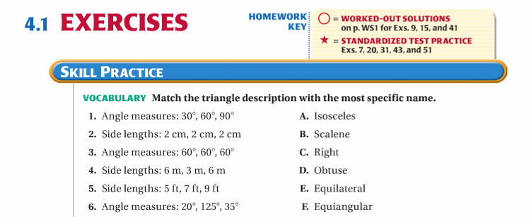
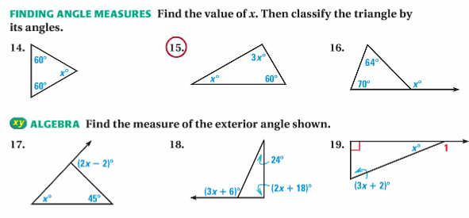

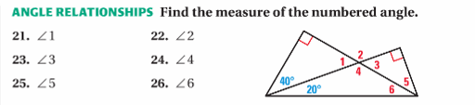

Lesson 1 Homework  BACK PAGE | LT 4.1 | 1-6, 14-18, 21-26 (FRONT PAGE)  32, 33, 35, 15, 16 (BACK PAGE)
